Perez-Wilson
Spiral Flow Mold Test (P4-9 to P4-30)
Wire Bonding Process (P4-32 to P-37)

REFERENCES
- Barrentine, Larry. Concepts for R&R Studies (GR&R). ASQ, 2003.
- Montgomery, Douglas, et al. Design and Analysis of Gauge R&R Studies: Making Decisions with Confidence Intervals in Random and Mixed ANOVA Models. ASA SIAM, 2005.
- ———. Introduction to Statistical Quality Control. Fifth Edition, Wiley, 2005.
- Perez-Wilson, Mario. Gauge R&R Studies For Destructive and Non-Destructive Testing. Advanced Systems Consultants, 2003, www.mpcps.com.

Contents
Experimental Design and Statistical Model 3
DGR&R Derivation of Model EMS Table 3
Page 3-3 – Difference between Destructive and Standard GR&R 4
Page 3-4 Model equation (nested) for DGR&R 5
Page 3-13 ANOVA Expected Mean Square (EMS) terms 5
Page 3-13 Calculate Variance Components from Model EMS terms 5
EXAMPLE: Perez-Wilson Spiral Flow Mold Test (P4-9 to P4-30) 6
METHOD 1: FIT FIXED EFFECTS ANOVA MODEL 7
ANOVA table 7
Combine MS terms to extract variance components 8
Verify Output 9
Calculate “sigma” terms ( = sqrt(varcomp) ) 10
Verify Output 10
Calculate GR&R terms from sigma terms and study_sigma 11
Verify Output 11
METHOD 2: FIT NESTED RANDOM EFFECTS MODEL with REML 12
LMER model with REML output 12
CALCULATE VARIANCE COMPONENTS from Variance-Covariance Matrix (VarCorr) 13
Calculate GR&R terms from sigma terms and study_sigma 14
METHOD 3 – MINITAB DGR&R (nested GRR) OUTPUT 15
METHOD 4 – MINITAB GLM OUTPUT using nested, random effects 17

Experimental Design and Statistical Model

DGR&R Derivation of Model EMS Table
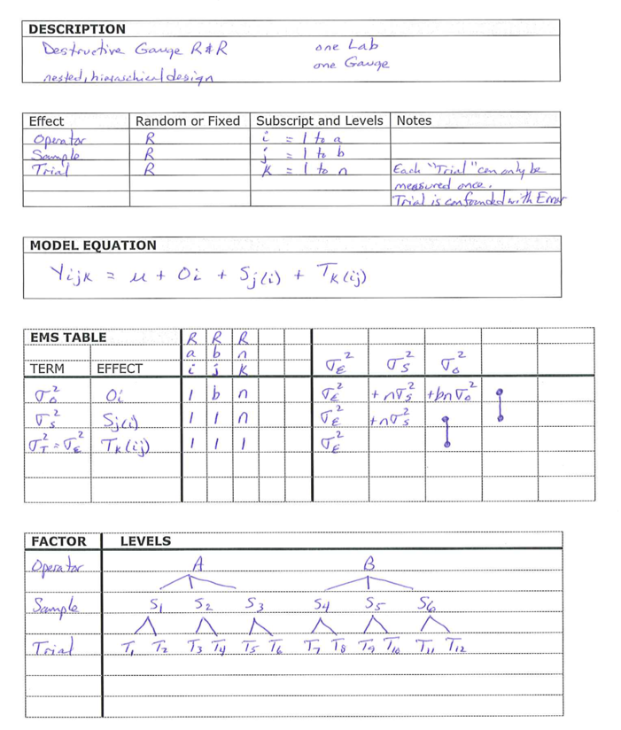

Page 3-3 – Difference between Destructive and Standard GR&R
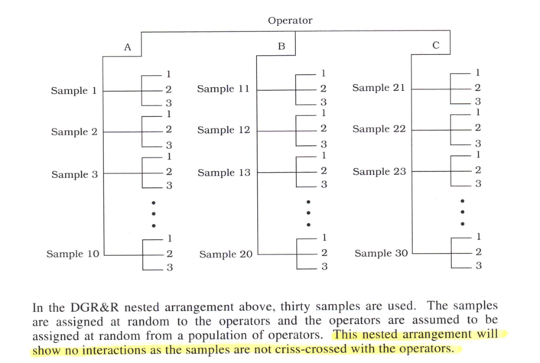

Page 3-4 Model equation (nested) for DGR&R
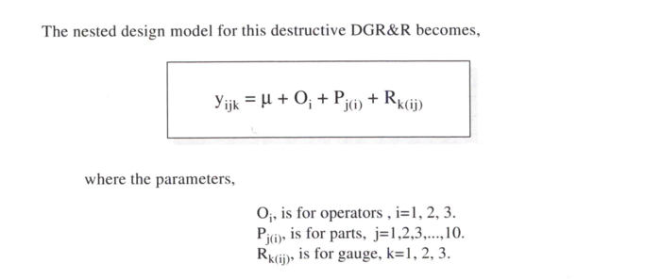

Page 3-13 ANOVA Expected Mean Square (EMS) terms
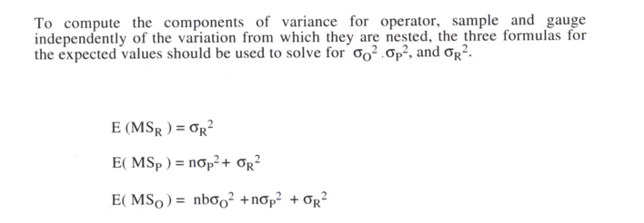

Page 3-13 Calculate Variance Components from Model EMS terms
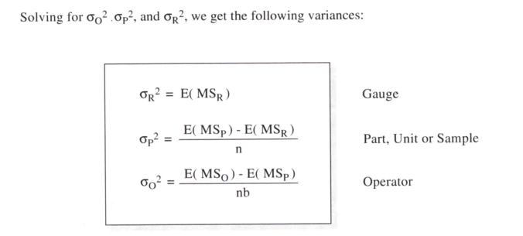

EXAMPLE: Perez-Wilson Spiral Flow Mold Test (P4-9 to P4-30)

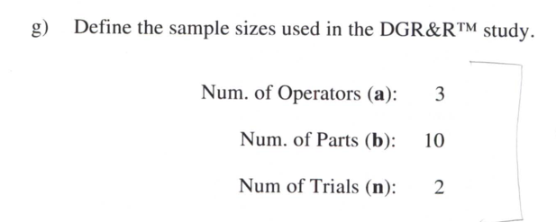

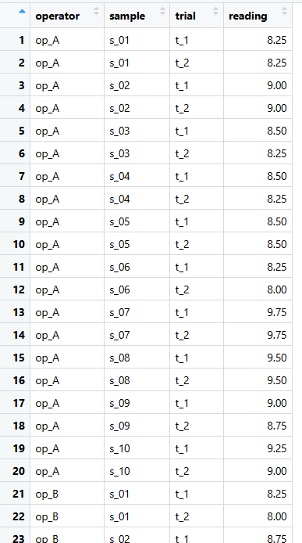

METHOD 1: FIT FIXED EFFECTS ANOVA MODEL

Use Fixed Effects ANOVA table to get SS, Df, and MS terms.

ANOVA table

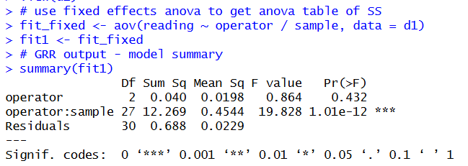

NOTE: all match in SS, Df, and MS columns.

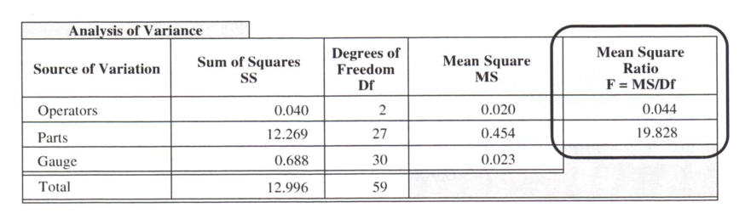
NOTE: The F-test will not always match in this case because in the R code we used a fixed effects ANOVA model, with nesting, to calculate the SS and MS terms.

Combine MS terms to extract variance components

Extract MS terms from model output.
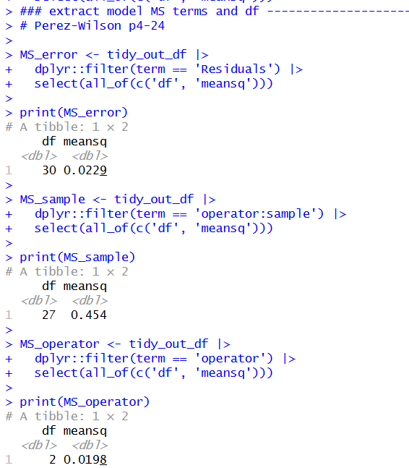

Verify a (number of operators), b (number of samples), and n (number of Trials) from the model output.
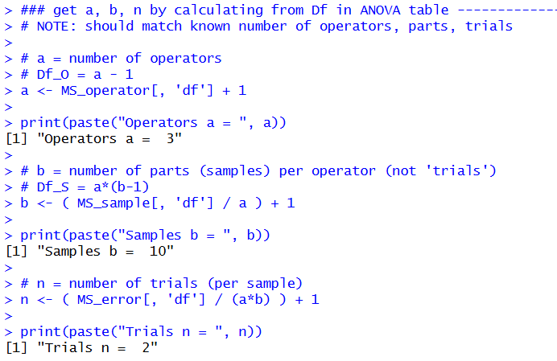

Calculate variance components from MS terms

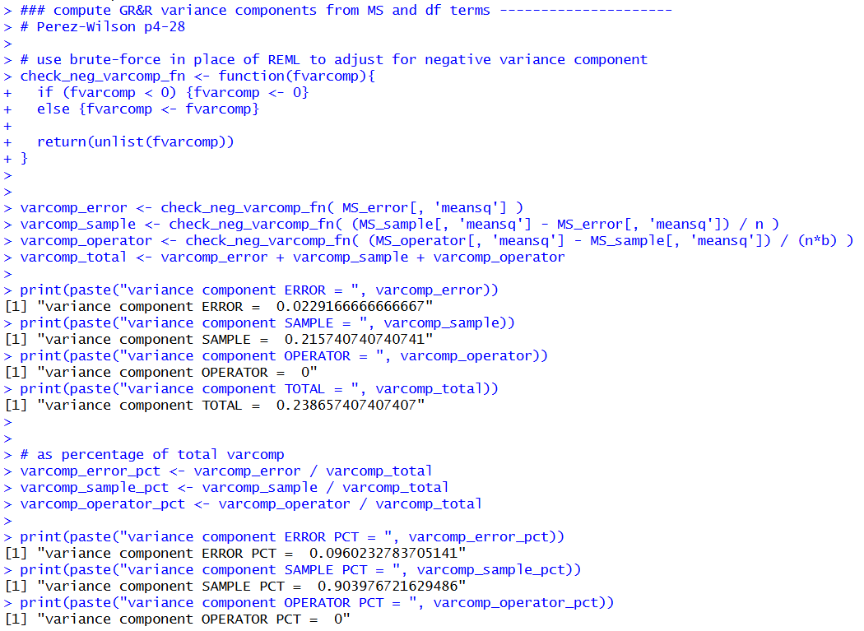

Verify Output
Note that the calculated variance components above match the output from Perez-Wilson.
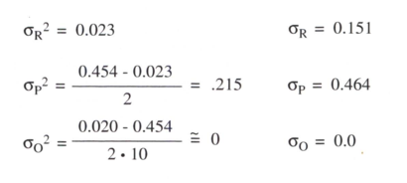

Calculate “sigma” terms ( = sqrt(varcomp) )

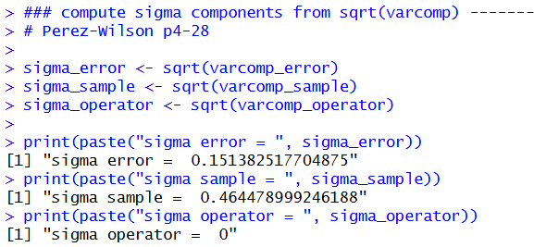

Verify Output
Note that the calculated sigma terms above match the output from Perez-Wilson.

Calculate GR&R terms from sigma terms and study_sigma

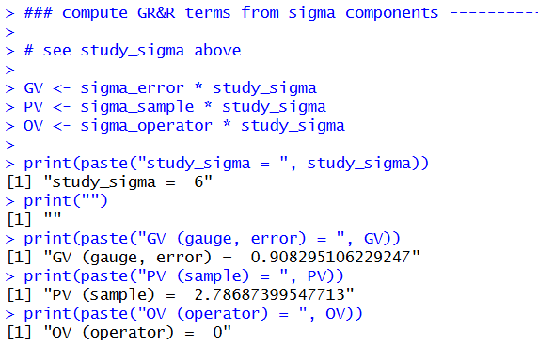

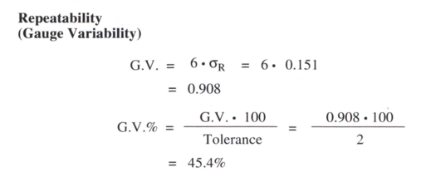 | 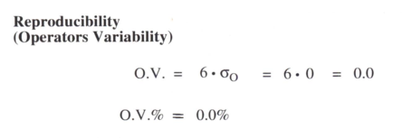

Verify Output
Note that the calculated GR&R components above match the output from Perez-Wilson.

REMINDER:
Because the “operator” variance component is less than zero (-0.434), we coerce the value to zero. This was a common practice historically. However, we have a better option using the Restricted Maximum Likelihood (REML) method.

METHOD 2: FIT NESTED RANDOM EFFECTS MODEL with REML

LMER model with REML output

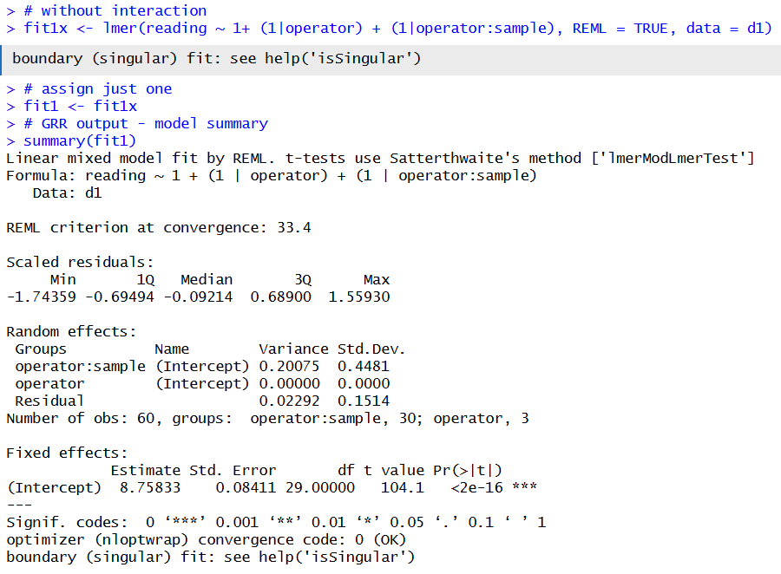

CALCULATE VARIANCE COMPONENTS from Variance-Covariance Matrix (VarCorr)

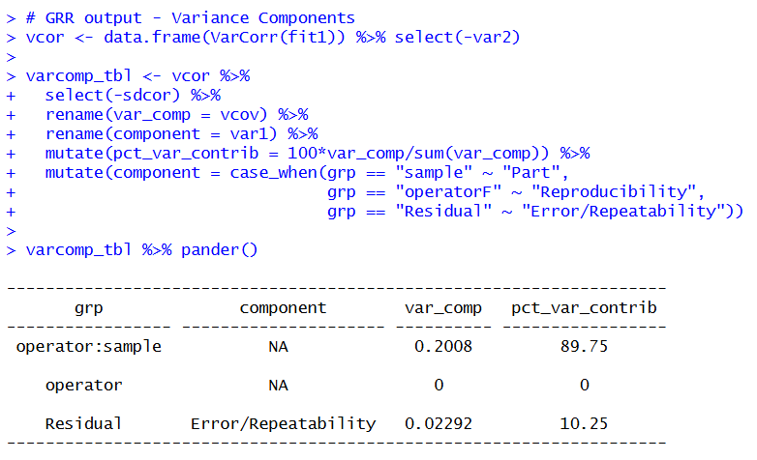

Calculate GR&R terms from sigma terms and study_sigma

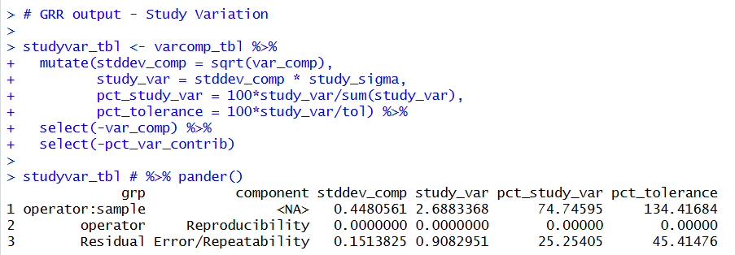

METHOD 3 – MINITAB DGR&R (nested GRR) OUTPUT

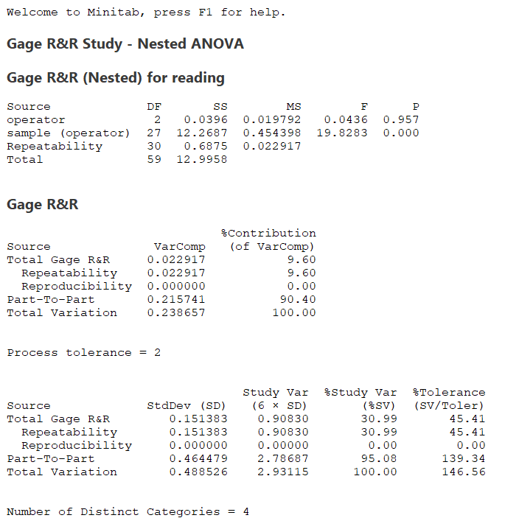
The Minitab (v17) results using the “nested GR&R” model match the MPW example.

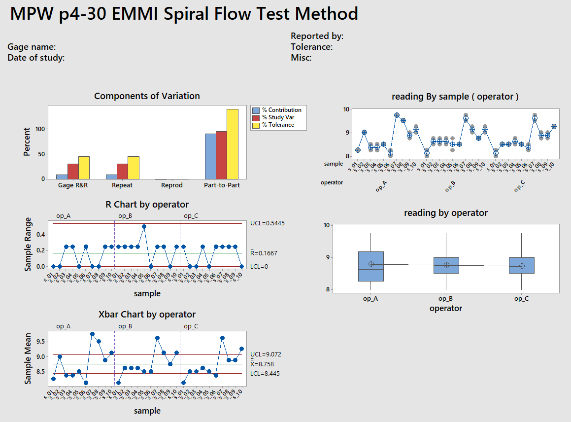

METHOD 4 – MINITAB GLM OUTPUT using nested, random effects

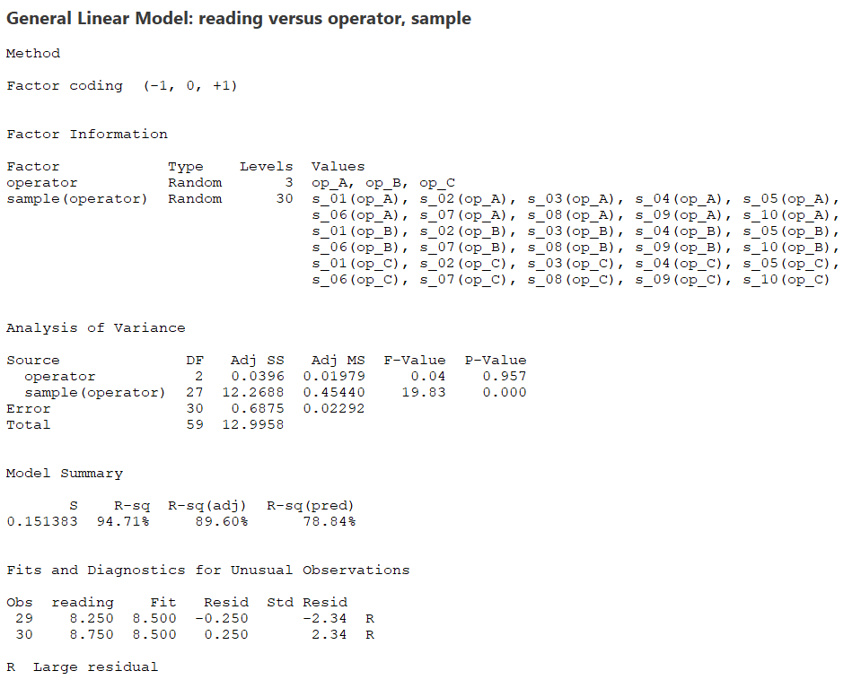

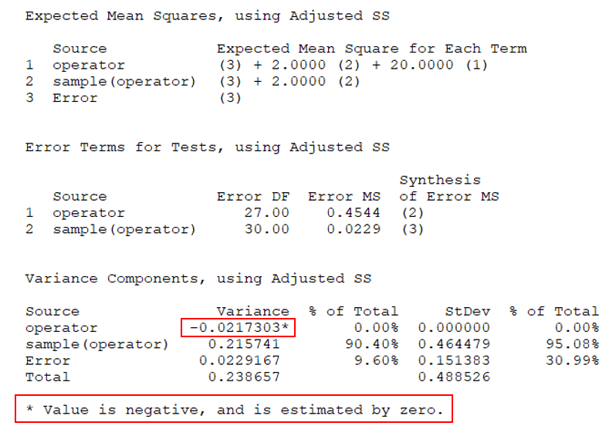
Minitab (v17) does not offer the REML method.

